Molecular characterization and isolation of Infectious laryngotracheitis virus (ILTV) strains causing outbreaks in layer chicken farms of Kalubia Province, Egypt
Abstract
Infectious Laryngotracheitis (ILT) is an acute highly contagious respiratory disease of chickens. It has significant economic importance due to mortalities and the drop in egg production. In this study, seventy samples from different layer farms were collected from the outbreaks that occurred in Kalubia province, Egypt, at the period from February 2018 till May 2019 to detect ILTV by molecular characterization through polymerase chain reaction assay (PCR) as well as isolation on the specific pathogen free- embryonated chicken eggs (SPF-ECEs) through chorioallantoic membrane (CAM) route. Post mortem examination of infected chickens revealed hemorrhagic tracheitis with fibrino-hemorrhagic casts and caseated materials. The PCR revealed amplification of a 688bp fragment of Infected Cell Protein 4 (ICP4) gene. Following that, seven samples were sequenced and phylogenetically analyzed. Sequence analysis of the ICP4 gene of these samples revealed complete identity with TCO (tissue culture origin) vaccines and the vaccine-related strains, which were previously isolated from Giza, Sharkia, Kafrelsheikh, and Fayoum provinces through the years 2007 to 2018. Inoculation of ILTV PCR positive samples on SPF-ECE appeared as yellowish-white pock lesions on the inoculated CAM from the first passage. From these results, we can say that ILTV circulating in Egypt is a vaccinal strain that regains its virulence from the back passage in birds and causes outbreaks all over the country.

Keywords: ILTV, Egypt, PCR, ICP4, CAM.

1.Introduction
Infectious laryngotracheitis (ILT) is an extremely contagious, upper respiratory tract infection of the poultry, causing substantial economic damage in chicken farms due to high mortalities, reduced growth, and a significant decline in egg production (Chacón et al., 2010).
The disease induces respiratory symptoms in chickens, pheasants, partridges, and peafowl. Sneezing, gasping, gurgling, rattling, wet rales, conjunctivitis, neck extension, and coughing of clotted blood are the predominant clinical signs in addition to reduced egg production and high mortalities (Lee et al., 2012).
ILT is caused by Gallid herpesvirus type 1 (GaHV‐1) related to Iltovirus genus, Alphaherpesvirinae subfamily of the family Herpesviridae and finally within order Herpesvirales (García, 2008). The GaHV‐1 genome is a linear double‐stranded DNA molecule composed of a unique long (UL) and unique short (US) region flanked by inverted terminal repeats (Leib et al., 1987).
The first outbreak of the disease was reported in Egypt with significant hemorrhagic tracheitis in layers in the province of Cairo and Giza in late 1982 and early 1983 (Tantawi et al., 1983). Another outbreak of the disease was reported in commercial layer chicken flocks, in Sharkia Province, Egypt in 2011 which was identified by sequencing of glycoprotein G (gG) and thymidine kinase (TK) genes (Ali et al., 2014). Another ILTV outbreaks pursued in poultry farms in Behera province and four strains of ILTV were isolated at the period between 2007 and 2010 from cross-bred chicken farms (Shehata et al., 2013) which were attributed to tissue culture origin (TCO) vaccine related strains. ILTV triggered an outbreak in Fayoum province in spring 2018 (Nourhan et al., 2019). Between January 2018 and May 2019, thirty farms in eight Egyptian governorates were confirmed to have ILT outbreaks (Bayoumi et al., 2020).
The diagnosis of GaHV1 necessitates laboratory validation because clinical symptoms and post mortem examination may be confusing as other poultry respiratory pathogens may cause related clinical signs and lesions. GaHV-1 diagnosis should be based on several tests, such as histopathological examination, virus isolation, and identification of GaHV1 antigens (Tripathy and García, 2015).
For clinical samples, detecting GaHV-1 via PCR is more sensitive and reliable than virus isolation, as presence of some viruses as adenoviruses that contaminate sample may prevent ILTV replication (Williams et al., 1994).
Recently, the ILTV Isolates have also been characterized by the sequence analysis of glycoprotein G (gG) gene, infected cell protein 4 (ICP4) and UL47. The ICP4 gene proved to be an effective and functional method for distinguishing between wild field isolates and vaccine strains (Chacon and Ferreira 2009).
Although GaHV‐1 was firstly propagated via inoculating the embryonating chicken egg (ECE), but it also can be propagated in several cell cultures including chicken embryo liver (CELi), chicken embryo lung (CELu), chicken embryo kidney (CEK), and chicken kidney (CK) cells (Hughes and Jones,1988).
ILTV still causing outbreaks in Egypt and leading to severe losses in layer farms all over the country. Previous studies revealed that it was a vaccinal strain. In our study, we aimed to know the reason for an outbreak that occurred in Kalubia province, Egypt and if it is a wild field strain or a circulating vaccinal strain. So, we perform a quick diagnosis by PCR, sequencing, and phylogenetic analysis then make a confirmation by isolation of the virus on ECE.
2.Materials and Methods
2.1. Clinical specimens
Seventy samples were obtained from different layer chicken farms in Kalubia province. These farms showed respiratory distress and some of them showed expectoration of blood. In post mortem (PM) examination they expressed hemorrhagic tracheitis, caseation in the tracheal lumen, and caseous laryngitis which represent the ideal pathognomonic lesions of ILT. The samples were collected in the period between February 2018 till May 2019 and these include the larynx, trachea, and lungs. These samples were preserved at -80 till usage to confirm the diagnosis by PCR and ILTV isolation. From the collected seventy samples only seventeen samples (have clear ILT lesions with no vaccination history) were taken for molecular characterization and then seven of them to be sequenced. Post mortem examination of field cases revealed congested tracheal mucosa, hemorrhagic tracheitis, presence of caseated material and blood clots along the lumen of trachea and some cases showed caseous material blocked laryngeal lumen as shown in Fig. (1).
2.2. DNA Extraction and PCR amplification
Complete DNA extracted from prepared tissue samples using QIAamp DNA Mini Kit (QIAGEN, Hilden, Germany, Catalogue no.51304) in accordance with manufacturer’s guidelines. In the tested samples ILTV was detected by amplifying portion of the gene ICP4. Seventeen samples were chosen from all seventy collected samples to be an indicator for the circulating strain in the province. Primers set was synthesized by Metabion (Germany) as the following:
ICP4-1F (forward) | ACTGATAGCTTTTCGTACCAGCACG
ICP4-1R (reverse) | CATCGGGACATTCTCCAGGTAGCA
Amplified segment 688 bp (Chacón and Ferreira ,2009)
PCR reaction was carried out in a total volume of 25 μl volume including 12.5 μl Emerald Amp GT PCR master mix (2x premix), 4.5 μl PCR grade water, 1 μl Forward primer, 1 μl Reverse primer, and 6 μl Template DNA. Cycling conditions of the used Primers are Primary Denaturation at 94˚C for 5 min. followed by Secondary Denaturation at 94˚C for30 sec., then Annealing at 62˚C for 40 sec, then Extension at 72˚C for 45 sec and then finally the Final Extension at 72˚C for 10 min. these for 35 cycles using T3 Thermal cycler (Biometra) (Chacón and Ferreira, 2009).
PCR products were then analyzed by 1.5% ethidium bromide-stained agarose gel, the gel was transferred to a UV cabinet. A gel documentation system photographed the gel, and data were analysed through computer software.
2.3. PCR products purification and sequencing
PCR product purified directly by QIAquick PCR Product extraction kit. (Qiagen Inc. Valencia CA). The purified PCR product was sequenced in both forward and reverse directions on an Applied Biosystems 3130 automated DNA Sequencer (ABI, 3130, USA). Using a ready reaction Bigdye Terminator V3.1 cycle sequencing kit. (Perkin-Elmer/Applied Biosystems, Foster City, CA), with Catalogue No. 4336817. The sequence reaction was done in accordance to the instruction of the manufacture.
A BLAST® analysis (Basic Local Alignment Search Tool) (Altschul et al., 1990) was conducted to determine sequence identity to GenBank accessions.
2.4. Phylogenetic analysis
A comparative analysis of sequences was conducted using the CLUSTAL W multiple sequence alignment program, version 1.83 of MegAlign module of Lasergene DNAStar software Pairwise, which was developed by Thompson et al., (1994), and Phylogenetic analysis were done using maximum likelihood, neighbor-joining, and maximum parsimony in MEGA6 program (Tamura et al., 2013).
2.5. Isolation of ILTV on CAM
The PCR positive samples (trachea and larynx) were minced using sterile iced mortar and pestle to prepare 10%suspensions in PBS (pH 7.2) solution containing Penicillin (1000IU/ml) and Streptomycin 100mg/ml). The suspension was centrifuged at 4°C for 15 minutes at 8000 rpm. The supernatant fluid of the sample (0.2ml) was inoculated into 12- day old SPF eggs (Kom Oshim farm for SPF-eggs, El-Fayoum, Egypt) via the chorioallantoic membrane (CAM) route for four passages, and control negative eggs inoculated with (0.2ml) PBS. The eggs were taken to be incubated at 37°C for 7 days then candled daily for mortalities and examined for lesions.
3. Results
3.1. Molecular detection of ILTV by PCR
PCR was performed for the field samples against a control negative sample. Out of seventeen tracheal samples, fifteen samples were GaHV-1 ICP4 PCR-positive: with an expected amplicon size of 688 bp as shown in Fig. (2).

3.2. Sequencing and phylogenetic analysis
Nucleotide sequencing and alignment were made for the ICP4 gene for only seven PCR positive samples and tested for their identity percent in comparison with reference strains obtained via GenBank Fig. (3) and Fig. (4)
Analysis of the nucleotide sequence of the ICP4 gene amplicon of seven field samples reveals that they share 100% homology with each other and with Fayoum 2018 strain (GenBank: MN082685.1), ILTV-EG/CLEVB-99/2015 (GenBank: MG279552.2) from Egypt and with the USDA strain (GenBankJN542534.1) reference strain. They share 97.6% homology with Laryngovac® (GenBank: FJ477350.1) and poulvac ILT® (GenBank: KP677882) that represent attenuated vaccines.
Phylogenetic analysis showed the closest relationship between the ILTV isolated in the present study with the USDA strain (GenBankJN542534.1) reference strain. The sequenced samples were published on GenBank and had accession numbers as shown in table (1).
3.3. Signs of ILTV on CAM of SPF-ECE
Isolation of virus was conducted through inoculation of supernatant of centrifuged collected field samples, trachea and larynx, into CAM of ECE. At first passage, generalized edema and yellowish-white pocks were observed on the CAMs of inoculated eggs with the viral suspensions from the first egg passage. In comparison to the CAM of non-inoculated control eggs, the membranes tended to be cloudy, and thickened Fig. (5).

4. DISCUSSION
ILT is an avian respiratory disease that causes significant economic losses in poultry production because of sever clinical symptoms. Laryngotracheitis is a significant respiratory disease of poultry and has a major economic effect worldwide on poultry industries (Bagust et al., 2000).
This study represents the rapid detection of ILTV with molecular characterization that caused an outbreak in commercial layer flocks in Kalubia province, Egypt. The clinical examination of the infected chickens revealed that they showed depression, dyspnea, conjunctivitis and some farms reported expectoration of blood. These represented same clinical signs reported by Hughes et al., (1991). Post mortem examination of field cases revealed congested tracheal mucosa, presence of caseated material and blood clots along the lumen of trachea and some cases showed caseous material blocked laryngeal lumen. These post mortem lesions are similar to those detected by Guy and Bagust, (2003); Moreno et al., (2010); Preis et al., (2013) and Bayoumi et al., (2020).
It is not possible to rely on clinical signs and PM only for diagnosis of ILTV, so other diagnostic methods are essential. So that, molecular characterization was done. PCR is an extremely adaptive ILTV recognition technique (Pang et al., 2002). The modified-live ILT vaccine viruses can infect susceptible birds and they also lead to field outbreaks of the disease (Guy et al., 1991). So, the differentiation between wild and vaccinal strains during outbreaks has a very critical role in disease control and also in surveillance studies. DNA sequence is the standard for genetic and molecular recognition for any virus (Lee et al., 2013). The nucleotide sequences obtained aid to compare various virus strains isolated in different geographical areas (Chacón et al., 2010).
Infected cell protein 4 (ICP4) gene is often used to assess the origin of the strain causing disease outbreaks even it is vaccinal strain or field strain of the virus (Chacón and Ferreira, 2009). PCR was performed for the field samples against a control negative sample. Out of seventeen tracheal samples, fifteen samples were GaHV-1 ICP4 PCR-positive with an expected amplicon size of 688 bp. This was the same as the result of (Nourhan et al.,2019 and Chacón and Ferreira, 2009).
Nucleotide sequencing and alignment were made for the ICP4 gene for only seven PCR positive samples and tested for their identity percent in comparison with reference strains obtained via GenBank.
The nucleotide sequence analysis of ICP4 gene amplicon of seven field samples reveals that they share 100% homology with each other and with Fayoum 2018 strain (GenBank: MN082685.1), ILTV-EG/CLEVB-99/2015 (GenBank: MG279552.2) from Egypt and with the USDA strain (GenBankJN542534.1) reference strain. They share 97.6% homology with Laryngovac® (GenBank: FJ477350.1) and poulvac ILT® (GenBank: KP677882) that represent attenuated vaccines. Phylogenetic analysis showed the closest relationship between the ILTV isolated in the present study with the USDA strain (GenBankJN542534.1) reference strain. Our findings from the nucleotide and amino acid sequence suggested that ILTV vaccinal strains may be the cause of the outbreaks in commercial layer chicken flocks in Kalubia, Egypt, although, the samples were taken from unvaccinated flocks. These findings are compatible with results by Shehata et al., (2013); Magouz, (2015) and Nourhan et al., (2019) who observed that ILT viruse in outbreaks was related to vaccinal strain and so this suggested that viruses from CEO and TCO-ILT vaccines regain their virulence from bird-to-bird back passages and so can leading to serious outbreaks in susceptible flocks in Egypt.
Also, these results are in agreement with the results obtained by Oldoni and García, (2007) Who showed that the vaccine strain was deeply related to most commercial poultry isolates of ILTV. Such outbreaks have shown that now the wild circulating virus is replaced by ILT vaccinal strain (Chang et al., 1997). These findings highlight the importance of using recombinant DNA-based vaccines and implementing biosecurity steps to reduce the chance of ILTV spread. Further epidemiological studies are expected in the context of ILTV circulation in Egypt, including chickens from the backyard.
The second step for the presence of ILTV was the isolation on ECE by CAM route. The gold standard approach for ILTV diagnosis is still viral isolation (Guy and Bagust, 2003). The virus suspension was inoculated in ECE via the CAM route, generalized edema and yellowish-white pocks were formed on the CAMs of inoculated eggs that appeared from the first passage.In comparison to Non-inoculated CAM, the membrases look cloudy and somewhat thickened.

Pock lesion detected after two passages by Ali et al., (2014) while detected after three passages by Magouz, (2015) and after four passages by Islam et al., (2010), opposite to pock lesions in our finding which showed pocks rapidly on CAM at the first passage. This may could be related to the high viral concentration and the great adaptability of the virus to ECE.
5. Conclusion
ILTV molecularly characterized and isolated from the clinical cases of ILTV outbreaks of Kalubia province was related to vaccinal strains. This means that the virus circulating is a vaccinal strain that regains its virulence from back passage in birds. It may be due to recombination between modified attenuated vaccines or appeared from latency from neighbor vaccinated flocks. It is recommended to use new vectored vaccines to avoid recirculation of vaccinal virus strains in the field.

Table.1: Molecular identified strains with their accession numbers.
Strain  N0. | Strain ID | Accession number
1 | ILTv EGY-BU Sh1.2018 | MT199131
2 | ILTv EGY-BU Sh2.2018 | MT199132
3 | ILTv EGY-BU Sh3.2019 | MT199133
4 | ILTv EGY-BU Sh4.2019 | MT199134
5 | ILTv EGY-BU Sh5.2019 | MT199135
6 | ILTv EGY-BU Sh6.2019 | MT199136
7 | ILTv EGY-BU Sh7.2019 | MW512848

Acknowledgment
I would like to thank Dr. Hanan Mohamed Elzahed, Chief Researcher at Central Laboratory for Evaluation of Veterinary Biologics (CLEVB), for providing facilities and help during virus isolation.

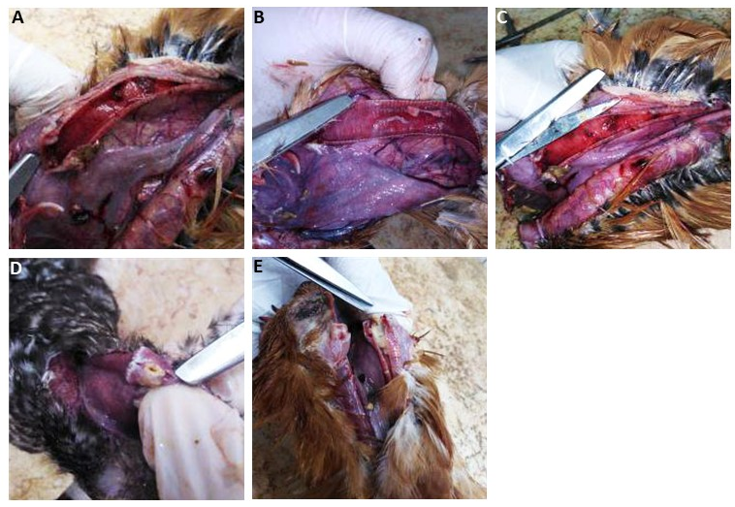

Fig.1: (A) Congested mucosa, Blood clots, and caseated material along the tracheal lumen. (B) Caseous material in tracheal lumen. (C)Hemorrhagic tracheitis and blood clots along the trachea. (D&E) Caseous material blocking laryngeal lumen.

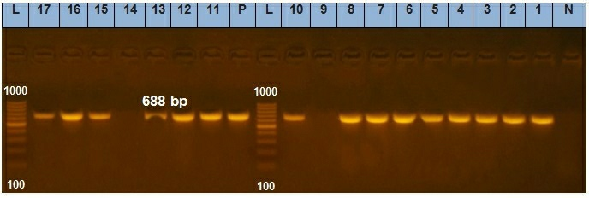
Fig.2: PCR amplification of 688pb of ICP4 gene from ILTV infected field samples. Lane L; 1000 bp DNA size marker. Lane C; Control positive. Lane N; Negative control. Lanes 1-17 represent the samples from all 9 and 14 were the only negative results.

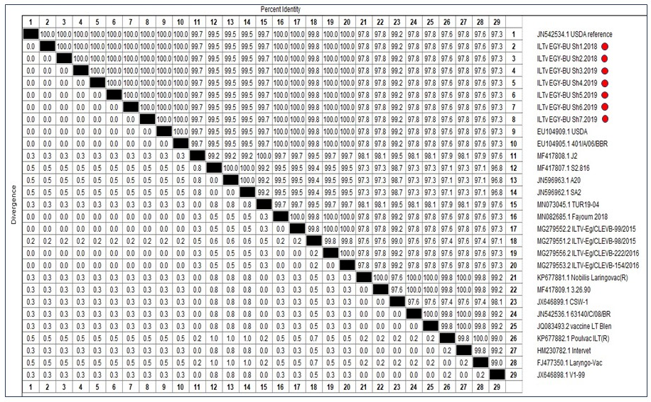
Fig.3: The identity % between identified strains with red spots and the reference ones on GenBank.

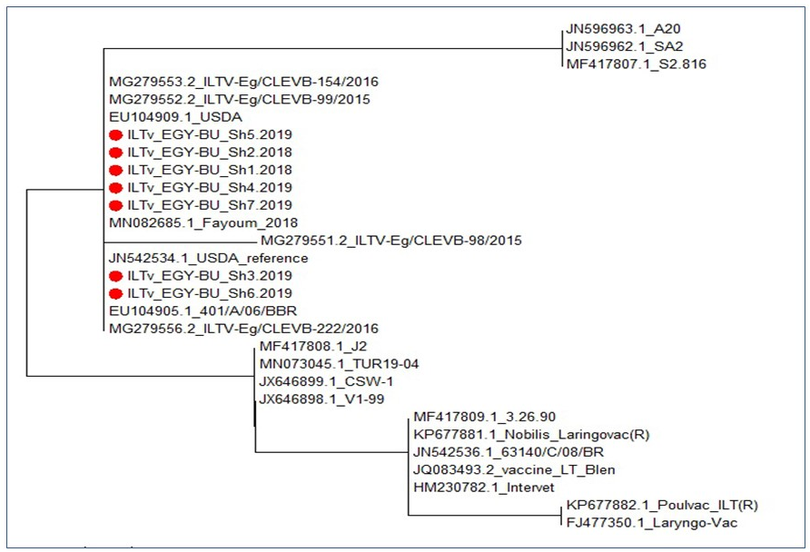
Fig.4: Phylogenetic analysis of ICP4 gene of ILTV identified samples. Phylogenetic analysis was done using MEGA6 program. The tree was constructed via multiple alignments of amino acids sequences of ICP4 gene and was analyzed by neighbor-joining analysis with 1000 bootstrap replicates. Samples of our study are marked by red spots.

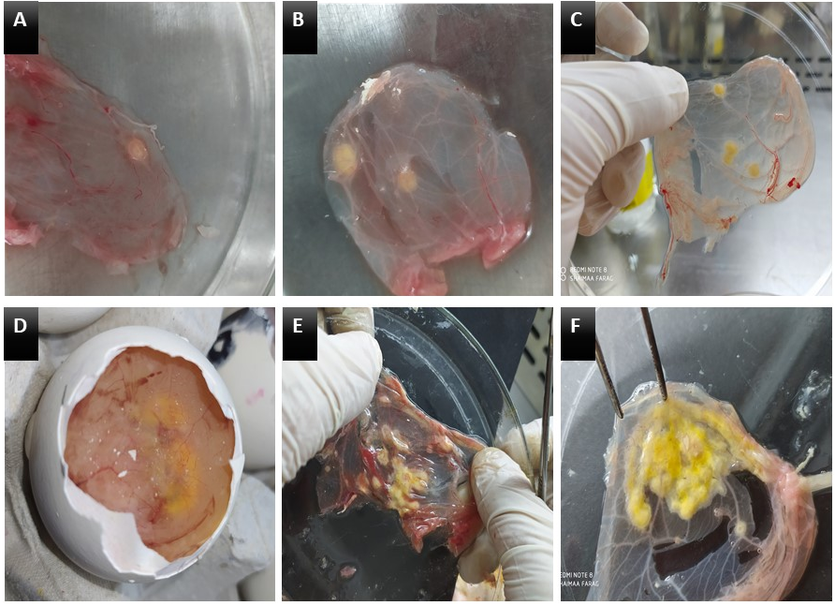

Fig.5: Chorioallantoic membranes (CAM) inoculated with a homogenate of infected field samples showing yellowish-white pock lesions (A&B) CAM of 1st passage, (C) 2nd passage CAM, (D&E) yellow shadow of pocks on 3rd passage egg (black arrow) and after harvesting the membrane showed aggregation of pocks, (F) 4th passage CAM.

6. References
- Ali, A., Mansour, S., Mohamed, M., Ali, H. and Shahin, A., 2014. Molecular characterization of thymidine kinase and glycoprotein G genes from a possible vaccine induced infectious laryngotracheitis outbreak in Egypt. Pak. Vet. J, 34, pp.381-385.
- Altschul, S.F., Gish, W., Miller, W., Myers, E.W. and Lipman, D.J., 1990. Basic local alignment search tool. Journal of molecular biology, 215(3), pp.403-410.
- Bagust, T.J., Jones, R.C. and Guy, J.S., 2000. Avian infectious laryngotracheitis. Revue scientifique et technique (International Office of Epizootics), 19(2), pp.483-492.
- Bayoumi, M., El-Saied, M., Amer, H., Bastami, M., Sakr, E.E. and El-Mahdy, M., 2020. Molecular characterization and genetic diversity of the infectious laryngotracheitis virus strains circulating in Egypt during the outbreaks of 2018 and 2019. Archives of virology, 165(3), pp.661-670.
- Chacón, J.L. and Ferreira, A.J.P., 2009. Differentiation of field isolates and vaccine strains of infectious laryngotracheitis virus by DNA sequencing. Vaccine, 27(48), pp.6731-6738.
- Chacon, J.L., Mizuma, M.Y. and Piantino Ferreira, A.J., 2010. Characterization by restriction fragment length polymorphism and sequence analysis of field and vaccine strains of infectious laryngotracheitis virus involved in severe outbreaks. Avian Pathology, 39(6), pp.425-433.
- Chang, P.C., Lee, Y.L., Shien, J.H. and Shieh, H.K., 1997. Rapid differentiation of vaccine strains and field isolates of infectious laryngotracheitis virus by restriction fragment length polymorphism of PCR products. Journal of virological methods, 66(2), pp.179-186.
- García M., 2008. Laryngotracheitis. In: Saif YM, Fadly AM, Glisson JR, McDougald LR, Nolan LK, Swayne DE (eds) Diseases of poultry, 12th edn. Blackwell Publishing, Oxford, pp. 137–152
- Guy, J.S., Barnes, H.J. and Smith, L., 1991. Increased virulence of modified-live infectious laryngotracheitis vaccine virus following bird-to-bird passage. Avian diseases, pp.348-355.
- Guy J.S. and Bagust T.J., 2003. Laryngotracheitis. In: Diseases of Poultry, Eleventh Edition, Saif Y.M., Barnes H.J., Glisson J.R., Fadly A.M., McDougald L.R. and Swayne D., eds. Iowa State University Press, USA, pp. 124 -134.
- Hughes, C.S. and Jones, R.C., 1988. Comparison of cultural methods for primary isolation of infectious laryngotracheitis virus from field material. Avian Pathology, 17(2), pp.295-303.
- Hughes CS, Williams RA, Gaskell RM, Jordan FT, Brandbury JM and Bennett M.,1991. Latency and reactivation of infectious laryngotracheitis vaccine virus. Arch Virol; 121:213-8.
- Islam, M.S., Khan, M.S.R., Islam, M.A. and Hassan, J., 2010. Isolation and characterization of infectious laryngotracheitis virus in layer chickens. Bangladesh Journal of Veterinary Medicine, 8(2), pp.123-130.
- Lee, J., Bottje, W.G. and Kong, B.W., 2012. Genome-wide host responses against infectious laryngotracheitis virus vaccine infection in chicken embryo lung cells. BMC genomics, 13(1), pp.1-13.
- Lee, S.W., Devlin, J.M., Markham, J.F., Noormohammadi, A.H., Browning, G.F., Ficorilli, N.P., Hartley, C.A. and Markham, P.F., 2013. Phylogenetic and molecular epidemiological studies reveal evidence of multiple past recombination events between infectious laryngotracheitis viruses. PloS one, 8(2), p.e55121.
- Leib, D.A., Bradbury, J.M., Hart, C.A. and McCarthy, K., 1987. Genome isomerism in two alphaherpesviruses: herpesvirus saimiri-1 (herpesvirus tamarinus) and avian infectious laryngotracheitis virus. Archives of virology, 93(3-4), pp.287-294.
- Magouz, A., 2015. Isolation and molecular characterization of Infectious Laryngotracheitis virus from naturally infected layer chicken flocks in Egypt. Global Veterinaria, 14(6), pp.929-934.
- Moreno, A., Piccirillo, A., Mondin, A., Morandini, E., Gavazzi, L. and Cordioli, P., 2010. Epidemic of infectious laryngotracheitis in Italy: characterization of virus isolates by PCR–restriction fragment length polymorphism and sequence analysis. Avian diseases, 54(4), pp.1172-1177.
- Nourhan, N., Mahmoud, S., Radwan, A., Hamed, R., Mahmoud, A.E.M., Adel, N. and EL-Zahed, H.M., 2019. Isolation and molecular characterization of circulating infectious laryngotracheitis (ILT) virus in Egypt, j. Egypt. vet. med. Assoc, 79, pp.743-759.
- Oldoni, I. and García, M., 2007. Characterization of infectious laryngotracheitis virus isolates from the US by polymerase chain reaction and restriction fragment length polymorphism of multiple genome regions. Avian Pathology, 36(2), pp.167-176.
- Pang, Y., Wang, H., Girshick, T., Xie, Z. and Khan, M.I., 2002. Development and application of a multiplex polymerase chain reaction for avian respiratory agents. Avian diseases, 46(3), pp.691-699.
- Preis, I.S., Braga, J.F., Couto, R.M., Brasil, B.S., Martins, N.R. and Ecco, R., 2013. Outbreak of infectious laryngotracheitis in large multi-age egg layer chicken flocks in Minas Gerais, Brazil. Pesquisa Veterinária Brasileira, 33(5), pp.591-596.
- Shehata, A.A., Halami, M.Y., Sultan, H.H., Abd El-Razik, A.G. and Vahlenkamp, T.W., 2013. Chicken embryo origin-like strains are responsible for Infectious laryngotracheitis virus outbreaks in Egyptian cross-bred broiler chickens. Virus genes, 46(3), pp.423-430.
- Tamura, K., Stecher, G., Peterson, D., Filipski, A. and Kumar, S., 2013. MEGA6: molecular evolutionary genetics analysis version 6.0. Molecular biology and evolution, 30(12), pp.2725-2729.
- Tantawi, H.H., El Batrawi, A.M., Bastami, M.A., Youssef, Y.I. and Fawzia, M.M., 1983. Avian infectious laryngo-tracheitis in Egypt. I. Epidemiology, virus isolation and identification. Veterinary research communications, 6(1), pp.281-287.
- Thompson, J.D., Higgins, D.G. and Gibson, T.J., 1994. CLUSTAL W: improving the sensitivity of progressive multiple sequence alignment through sequence weighting, position-specific gap penalties and weight matrix choice. Nucleic acids research, 22(22), pp.4673-4680.
- Tripathy, D.N., and M. García. 2015. Laryngotracheitis. In: A Laboratory Manual for the Isolation and Identification of Avian Pathogens. American Association of Avian Pathologists, Jacksonville, Florida. pp. 94–98.
- Williams, A. R., Savage, C.E. and Jones, R.C., 1994. A comparison of direct electron microscopy, virus isolation and a DNA amplification method for the detection of avian infectious laryngotracheitis virus in field material. Avian Pathology, 23(4), pp.709-720.

